Linux Fundamentals – Practical Assignment 01

Introduction
Linux is a widely used operating system in system administration, cloud computing, and DevOps. Learning Linux commands is an essential step toward managing files, working with text, controlling file permissions, and configuring the shell environment.
This assignment demonstrates the practical use of basic Linux commands through hands-on exercises and command-line verification.

Objectives
- Create, rename, and manage files and directories.
- View file contents and search for specific patterns.
- Compress and extract directories using ZIP utilities.
- Download files from the internet using wget.
- Manage file permissions using chmod.
- Set environment variables using export.

Environment
- Operating System: Linux / macOS terminal (as applicable)
- Interface: Command-Line Interface (CLI)
- Tools: Bash or a compatible shell, mkdir, mv, cat, head, tail, grep, zip, unzip, wget, chmod, and export.

Linux_Basic_Akash

Task 1: Create a directory named test_dir.

Objective:
Create a new directory to organize the files used in this assignment.

Command :
mkdir test_dir

Screenshot :

Task 2: Create an empty directory called example.txt inside test_dir.

Objective:

Create a new empty file inside test_dir

Command :

touch example.txt

Screenshot:

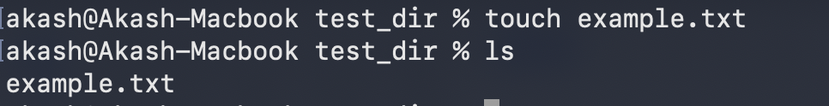

Task 3: Rename example.txt to renamed_example.txt using mv.

Objective:

Rename the file example.txt to renamed_example.txt using mv command

Command:

mv example.txt renamed_example.txt

Screenshot:

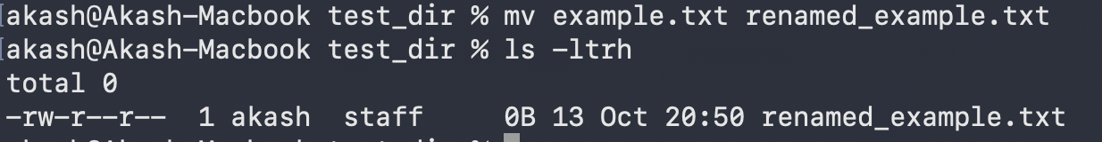

Task 4: Use cat to display the content of /etc/passwd .

Objective:

Display the contents of the /etc/passwd file using the cat command.

Command:

cat /etc/passwd

Screenshot:

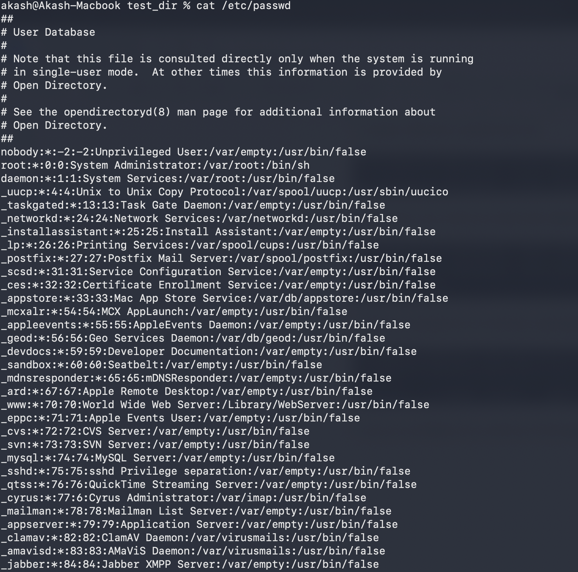

Task 5: Display only the first 5 lines of /etc/passwd using head

Objective :

To display the first five lines of the /etc/passwd

Command :

head n5 /etc/passwd

Screenshot :

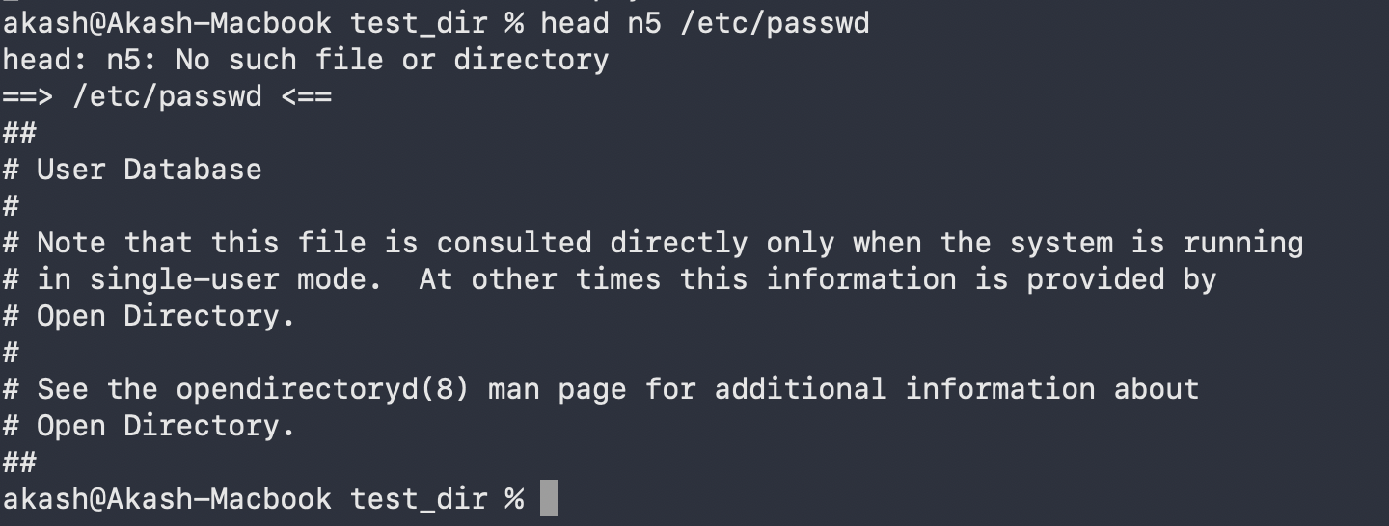

Task 6: Display only last 5 lines of /etc/passwd using tail

Objective :

To display last five line of /etc/passwd

Command :

tail n5 /etc/passwd

Screenshot :

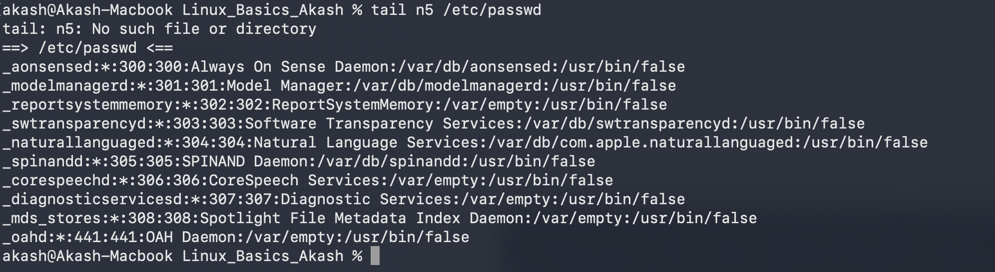

Task 7: Use grep to find all lines containing the word “root” in /etc/passwd .

Objective :

To search for and display all lines containing the word root in the /etc/passwd

Command :

grep “root” /etc/passwd

Screenshot :

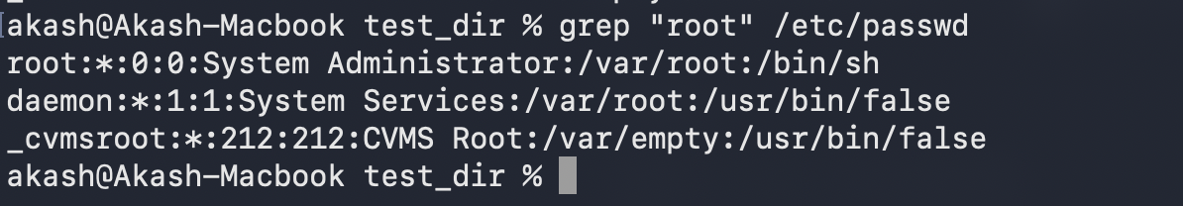

Task 8 : Compress the test_dir into a file named test_dir.zip using zip

Objective :

Compress test_dir into test_dir.zip

Command :

zip -r test_dir.zip test_dir

Screenshot :

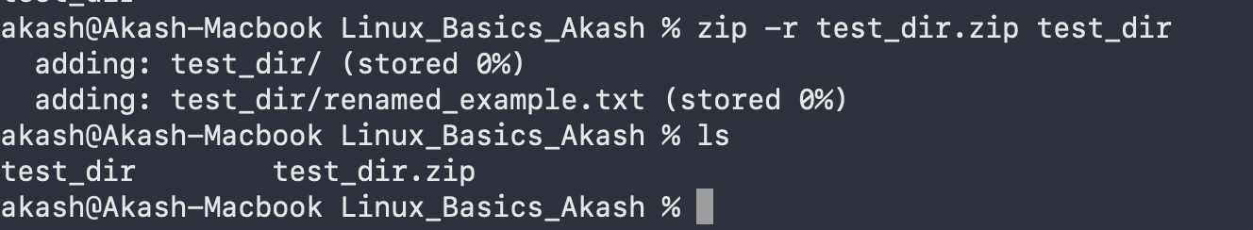

Task 9 : Unzip test_dir.zip into a new directory named unzipped_dir

Objective :

Unzip test_dir.zip into unzipped_dir

Command :

unzip test_dir.zip -d unzipped_dir

Screenshot :

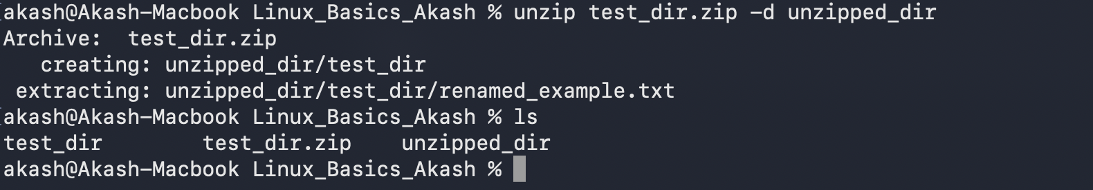

Task 10 : Use wget to download a file from a URL (e.g., https://example.com/sample.txt)

Objective :

To download a file from a special URL using the wget

Command :

wget https://www.gnu.org/licenses/gpl-3.0.txt

Screenshot :

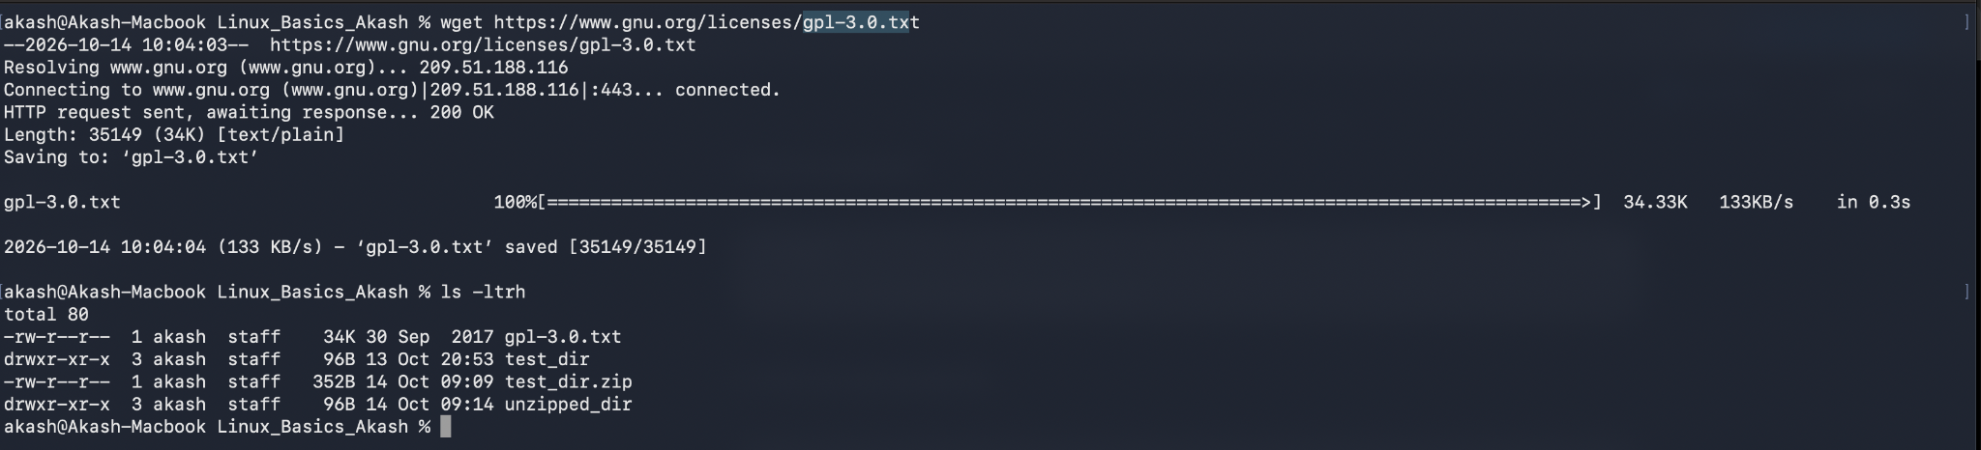

Task 11 : Create a file named secure.txt and change its permissions to read-only for everyone using chmod

Objective :

Modify file permissions to read-only for everyone using chmod

Command :
touch secure.txt
chmod 444 secure.txt

Screenshot :

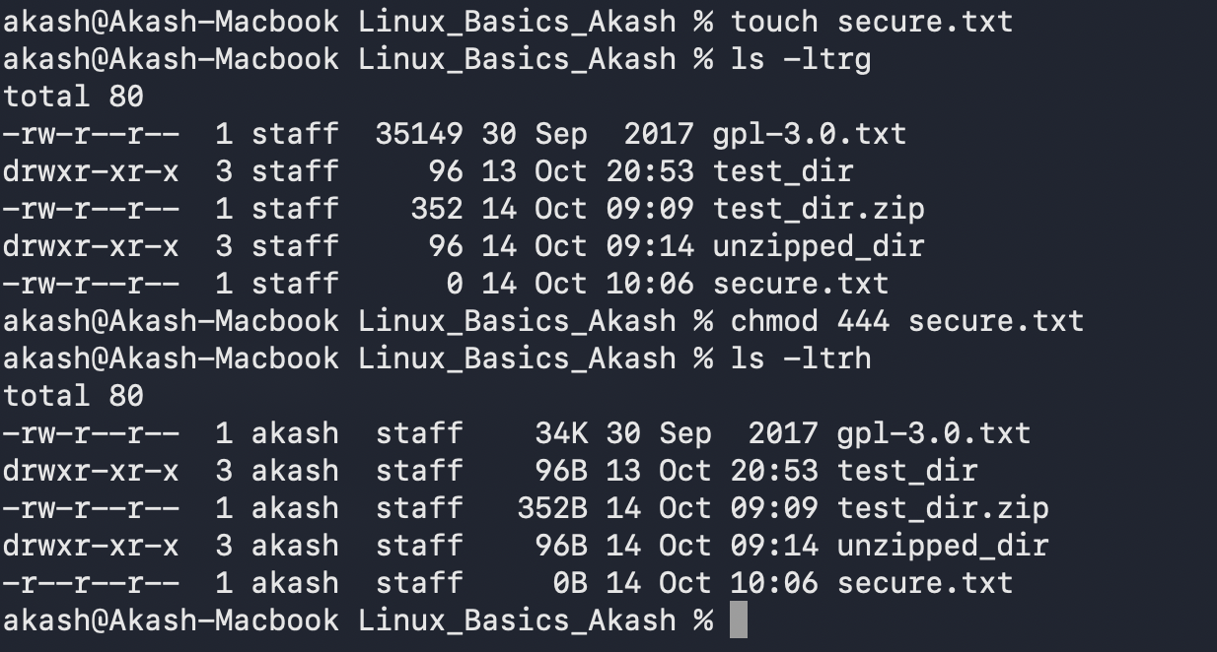

Task 12 : Use export to set a new environment variable called MY_VAR with the value “Hello, Linux!”.

Objective :

To create and export an environment variable named MY_VAR with the value Hello, Linux!

Command :

MY_VAR=”Hello Linux”
Export MY_VAR=”Hello Linux”

Screenshot :

